**“Online Fashion Exhibition”**

**A MINI PROJECT REPORT**

***Submitted by***

|  |  |
| --- | --- |
| **Anupama Mishra** | * **13AU/627** |
|  |  |
|  |  |
|  |  |

**MASTER OF COMPUTER APPLICATIONS**

***in***

**CENTRE OF COMPUTER EDUCATION**



**INSTITUTE OF PROFESSIONAL STUDIES**

UNIVERSITY OF ALLAHABAD

ALLAHABAD

**DECEMBER - 2015**

#### *CERTIFICATE*

This is to certify that the Major Project reportentitled **“Online Fashion Exhibition**” submitted by **ANUPAMA MISHRA** has been carried out under my guidance & supervision. The project report is approved for submission towards partial fulfillment of the requirement for the award of degree of **MASTER OF COMPUTER APPLICATIONS** in **CENTER OF COMPUTER EDUCATION**from “**INSTITUTE OF PROFESSIONAL STUDIES, UNIVERSITY OF ALLAHABAD, ALLAHABAD (U.P.)”**

MISS. TULIKA NARANG Prof. R.R.Tewari

(ProjectGuide) (HoD) **Centre of Computer Education**

# 

#### *DECLARATION*

We hereby declare that the project entitled **““Online Fashion Exhibition”** which is being submitted in partial fulfillment of the requirement for award of the Degree of OF COMPUTER APPLICATIONS in CENTER OF COMPUTER EDUCATIONto “**INSTITUTE OF PROFESSIONAL STUDIES, UNIVERSITY OF ALLAHABAD, ALLAHABAD (U.P.)”**

**Date: 21/12/2015**

##### Place: ALLAHABAD Anupama Mishra

#### *ACKNOWLEDGEMENT*

We sincerely express indebtedness to esteemed and revered guide “*Miss Tulika Narang*”, *Project Guide* in *Center Of Computer Education*for her invaluable guidance, supervision and encouragement throughout the work. Without her kind patronage and guidance the project would not have taken shape.

We take this opportunity to express deep sense of gratitude to “*Prof. R.R. Tewari*”, Head of “Center Of Computer Education”for his encouragement and kind approval. Also we thank him in providing the computer lab facility. We would like to express our sincere regards to him for advice and counseling from time to time.

We owe sincere thanks to all the lecturers in “Center Of Computer Education*”* for their advice and counseling time to time.

**Dated: 21/12/2015 Anupama Mishra**

##### Place: ALLAHABAD

***Table of Contents***

**Content Page No.**

1. **Introduction 6-8**
2. **Problem Definition 8**
3. **Requirements 9-12**
4. **Design 13-15**
5. **Cost Estimation 16**
6. **Implementation 17-24**
7. **Screen Shots 25-28**
8. **Application 29**
9. **Conclusion 30**
10. **References 31**

1. Introduction:

## Purpose

## Online fashion exhibition is a web based application, which allows organization to conduct exhibition online.

## The purpose of this Exhibition is to present collections of fashion items to a wider public, so the exhibition can reached and views worldwide.

## The users can easily see the exhibition online by sitting at his/her home. So it can save time and money.

## Project Scope

* + An exhibition in the most general sense, an organized presentation and
  + display of a selection of items such as modern and traditional dresses,

Jewelleries, foot wear, bangles, handbags and all accessories.

* + In this application, participants will register at the application and will

Post his/her products, stuffs and accessories at the website.

## Benefits of the Project:

* + It creates more interest in joining fashion industry.
  + It brings together skills and new ideas in new exciting ways.
  + Participants can show their talent through this exhibition.
  + It provides encourage design as a field and would give wider
  + perspective and a broader perception to the thought and idea of

tommrrow.

**Modules**

* Exhibitors Module

* Participants Module

**Exhibitors Module:**

* Exhibitors will create the exhibition and manage the exhibition.
* Exhibitors will manage the participants and user account.
* He will approve the participants, has right to update/ delete participants and

his/her accounts as well.

**Participants Module:**

* Participants will register at website. Once they will register he/she can post

his/her

* Products, stuffs and accessories according to given instructions and can

update and delete it also.

* A profile of participants will also be managed at this website.

## Limitations:

The query posted on the online fashion exhibition will be public to everyone. There is no content privacy setting for any user.

It is an online portal which will only accessed with proper network connection and browser support. The user should be computer literate to use the existing system.

It is designed to use within only the university or organization department.

1. ***Problem Definition***

The system is designed to make the users work of information gatheringover the internet easy.

* At the topmost of priority is the site administrator who is the super user and who holds the final authority over the dealings of the system
* At the next level is the registered user who is in the process of information gathering with the website. He is responsible for entering correct data and making changes in the choices entered if the system permits him to do so.
* At last is the anonymous user who visits the website to check its functionality and acts as a prospective candidate.

1. ***Requirements***

**Functional Requirements:**

The functional requirements include the various phases:

**1. login-** This phase refers to the authorization of the Exhibitors,participants and anonymous user.

**2. Registration-** Itincludes the registration process of the exhibitors, participants and visitors on the website before using the website.

**3. Create exhibition-**The website provides the facility for create various types of exhibition which is related to fashion world. Admin will create exhibition.

**4. Blogs post-**Participents who are designers will post the blocks of related topic and share the information how to design products in your home which can be seen by everyone who is the member of this website.

**5 .News post-** This website also provides news for exhibiton name, exhibition type, date, time. Visitors will always be aware for new events or exhibitions.

**6. Logout-**This functionality let user safely logout from his/her account for doing some another task the user has to relogin into their account.

**Other Nonfunctional Requirements**

**Performance Requirements**

Accountability is a vital feature and this could only be assured if the system is working in full capability. So Uninterrupted Power Supply is always recommended.

## Safety Requirements

The data handle in the system is very vital. The server should always be confirming to run properly and the data are saved to the data base at consecutive intervals.

Power is a significant feature and the power supply should be always taken care of. An Uninterrupted Power Supply is always recommended.

## Security Requirements

The security system features from having a login for all the users to access the site. The login details will be used for authentication for every individual so the chances of the site getting intruded are very less. Every user wants the system to be secure so that he/she will be confident on using **Online Fashion Exhibiton**. But security is not visible as-is, and need to be reflected in the usability. If there is an outage, the best to regain confidence of the customer is to be transparent with what happened.

* **Maintainability:**
  + - 1. **Back Up:**

The system shall provide the capability to back-up the data.

1. **Errors:**

The system shall keep a log of all the errors.

* **Reliability:**

1. **Availability:**

The system shall be available all the time.

* **Scalability:**

It should offer scalable solution i.e. it should able to offer same performance with growing number of patients.

**External Interface Requirements**

## User Interfaces

All pages of the system are following a consistent theme and clear structure. The occurrence of errors should be minimized through the use of checkboxes, radio buttons and scroll down in order to reduce the amount of text input from user. JavaScript implement in HTML in order to provide a Data Check before submission. HTML Tables and divisions to display information to give a clear structure that make it easy to understand by users. Error message should be located beside the error input which clearly highlight and tell user how to solve it. The page should display the project process in different color to clearly reflect the various states. Each level of user will have its own interface and privilege to mange and modify the project information such as Administrator is able to monitor/manage his user progress and make comment on it, user can change his detail, view the progress, submit project idea. The System should provide a feedback form for all users to give comments or asking questions.

## Hardware Interfaces

#### Server Side

The web application will be hosted on one of the server and connecting to the MySql Database server. The web server is listening on the web standard port, port 8080.

#### Client Side

The system is a web based application; clients are requiring using a modern web browser such as Mozilla Firebox, Internet Explorer, Google Chrome and Enable Cookies. The computer must have an Internet connection in order to be able to access the system.

## Software Interfaces

#### Server Side

The system already has the required software to host a php web application. An Apache Web server will accept all requests from the client and forward specific requests to Container hosting the Online Fashion Exhibition. A development database will be hosted using MySql.

#### Client Side

An OS is capable of running a modern web browser which supports all versions of HTML, DHTML, JavaScript, and CSS.

## Communications Interfaces

The HTTP protocol will be used to facilitate communications between the client and server. These protocols are used to establish a link between client system and the server.

## Operating Environment

The system is web based and will be hosted by a web server(Apache). It can be viewed by any web browser and has been tested for compliance with browsers like:

1. Mozilla Firefox
2. Google Chrome
3. Internet Explorer

**Some other technologies involved to build the system:**

1. Windows XP/ Windows 7
2. NuSphere phpED, Dreamweaver
3. MySql
4. Php, J2EE, HTML, DHTML,CSS, XML, JSP, SERVLET
5. **Design**

It should be done in 2 stages-

**Architectural Design**: it includes use case view

**Use Case diagram**

Use cases are used during the analysis phase of a project to identify and partition.

System functionality. They separate the system into actors and use case. Use cases describe the behavior of the system when one of these actors sends one particular stimulus. This behavior is described textually. It describes the nature of the stimulus that triggers the use case; the inputs from and outputs to other actors, and the behaviors that convert the inputs to the outputs.

**Use Case Diagram For Online Fashion Exhibition**

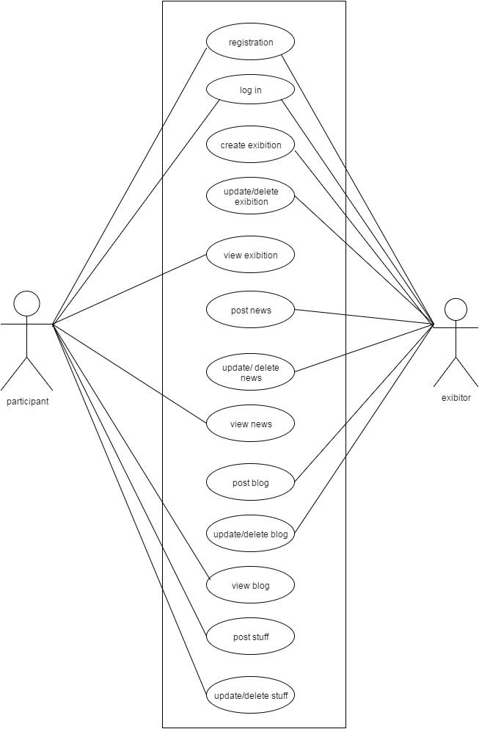

**Detailed Design**: The Detail design should contain Database, ERD, Class Diagram etc.

**ER- Diagrams**

An **entity-relationship (E-R) data model** is a high-level conceptual model that describes data as entities, attributes, and relationships. The E-R model is represented by ER diagrams that show how data will be represented and organized in the various components of the final database.

Here ER diagram represent the attributes and relationship among the three basic modules, *Administrator, User and Anonymous User*, of the project **online fashion exhibition**. There are also some supportive entities, which are required to support the functionality of the various users, are added.

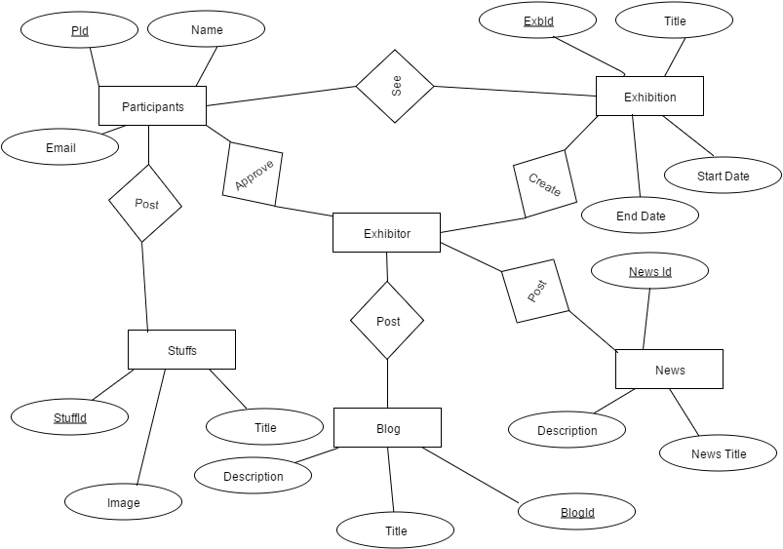

**Class Diagram**

The purpose of a class diagram is to depict the classes within a model. In an object oriented application, each class in a Class Diagram is simply a rectangle divided into three compartments. The topmost compartment contains the name of the class. The middle compartment contains a list of attributes (member variables), and the bottom compartment contains a list of operations (member functions). Relationships between the classes are how the classes communicate with each other. A solid line represents an association, which is a property of a class. Associations are used to represent relationships between objects

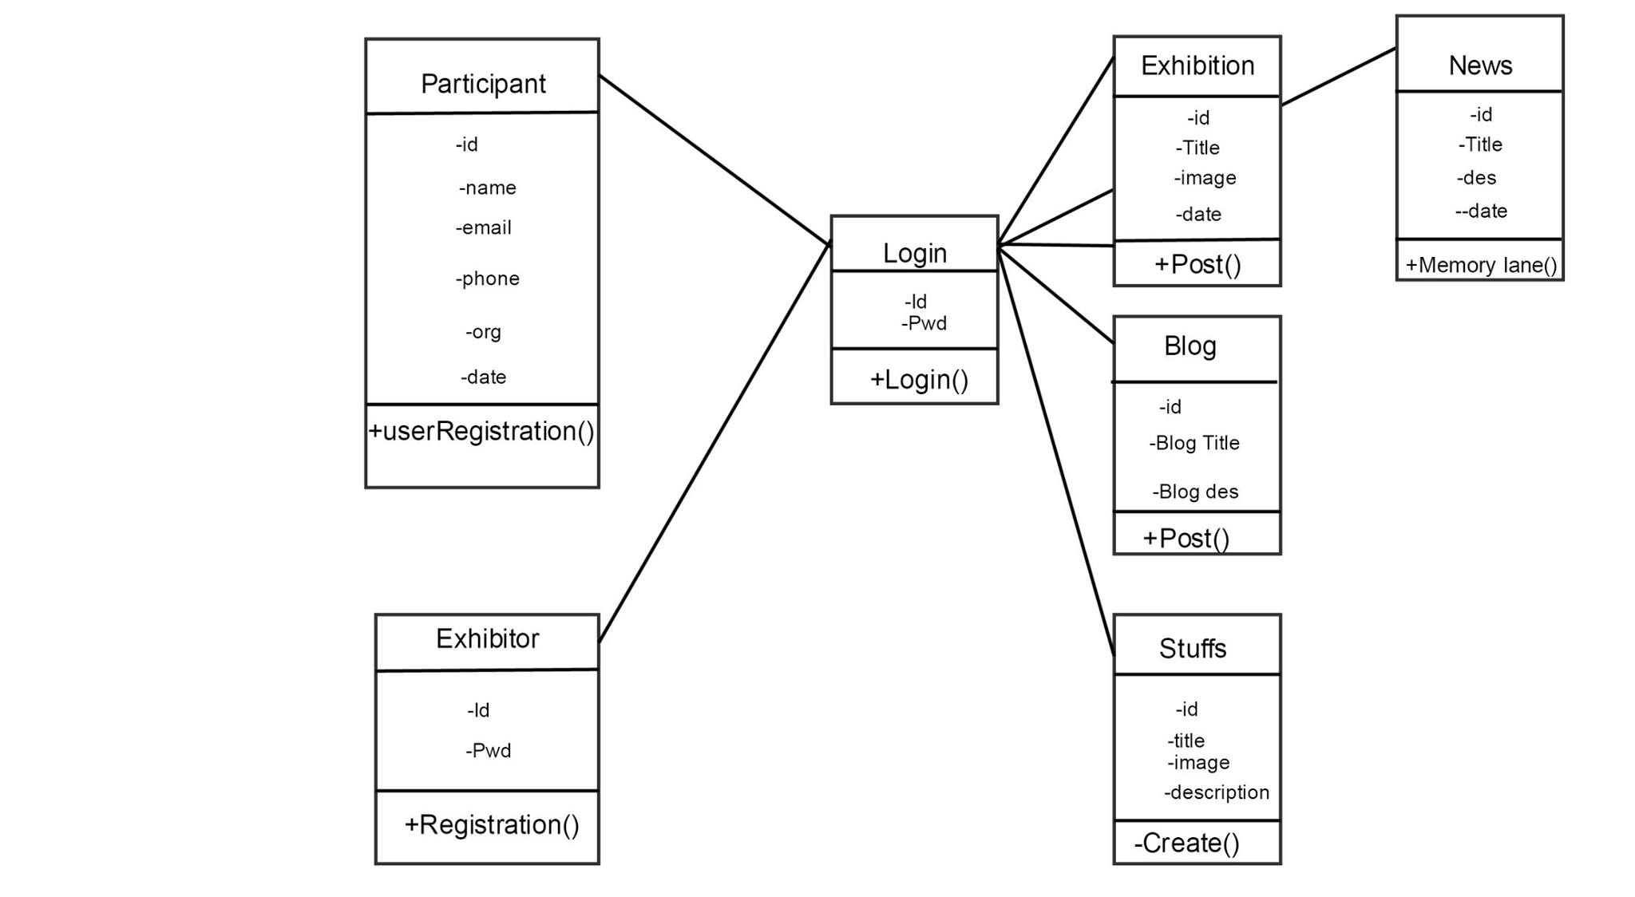

1. ***Cost Estimation***

Cost estimation is calculated through the COCOMO technique.

Online Fashion Exhibition project comes in the category of organic software development.

Characteristics of Organic software development:

* Well understood application program.
* Size of development team is small.
* Team members are experience in developing similar type of project.
* Requirements are already known.

**Formula used:**

* effort = a1 * ( KLOC) a2  PM
* Tdev = b1 * ( effort ) b2  month

**Where**

KLOC: kilo lines of codes.

Tdev : total development time

PM : PM(person month) is the unit of effort

**Values of constants**

**a1=2.4 b1=2.5**

**a2=1.05 b2=0.38**

by substituting the value of constants and KLOC( kilo lines of code in the project) formula given above , the total cost can be calculated**.**

1. ***Implementation***

**Login Page**

<!DOCTYPE html>

<html lang="en">

<head>

<meta charset="utf-8">

<title>Online Fashion Exhibition:</title>

<?php include "css.php";?>

</head>

<body>

<!--Header-->

<?php include "header.php"; ?>

<!--End Header-->

<!--slider-->

<section class="homepage-slider" id="home-slider">

<div class="flexslider">

<ul class="slides">

<li>

<img src="themes/images/carousel/banner-2.jpg" alt="" />

</li>

<li>

<img src="themes/images/carousel/banner-4.jpg" alt="" />

</li>

<li>

<img src="themes/images/carousel/banner-3.jpg" alt="" />

</li>

</ul>

</div>

</section>

<!--End of slider-->

<section class="header_text">

Online fashion exhibition is a web based application, which allows organization to conduct exhibition online, so the exhibition can be reached and views worldwide.

</section>

<!--Main Container-->

<section class="main-content">

<div class="row">

<!--Left column-->

<div class="span9">

<!--Ma Durga Images-->

<div class="row">

<div class="span9">

<h4 class="title">

<span class="pull-left"><span class="text"><span class="line">Running Exhibition <strong>Collections</strong> <a href=""></span> |<span class="see-all"> See All Stuffs</a></span></span></span>

<span class="pull-right">

<a class="left button" href="#myCarousel" data-slide="prev"></a><a class="right button" href="#myCarousel" data-slide="next"></a>

</span>

</h4>

<div id="myCarousel" class="myCarousel carousel slide">

<div class="carousel-inner">

<div class="active item">

<ul class="thumbnails">

<li class="span3">

<div class="product-box">

<p><a href="product_detail.html"><img src="images/thumb/330x190-3.jpg" alt="" /></a></p>

<a href="product_detail.html" class="title">indian dress beauty</a><br/>

<a href="products.html" class="category">By : Anupama Mishra</a><br/>

</div>

</li>

<li class="span3">

<div class="product-box">

<p><a href="product_detail.html"><img src="images/thumb/330x190-3.jpg" alt="" /></a></p>

<a href="product_detail.html" class="title">indian dress beauty</a><br/>

<a href="products.html" class="category">By : Anupama Mishra</a><br/>

</div>

</li>

<li class="span3">

<div class="product-box">

<p><a href="product_detail.html"><img src="images/thumb/330x190-3.jpg" alt="" /></a></p>

<a href="product_detail.html" class="title">indian dress beauty</a><br/>

<a href="products.html" class="category">By : Anupama Mishra</a><br/>

</div>

</li>

</ul>

</div>

<div class="item">

<ul class="thumbnails">

<li class="span3">

<div class="product-box">

<p><a href="product_detail.html"><img src="images/thumb/330x190-3.jpg" alt="" /></a></p>

<a href="product_detail.html" class="title">indian dress beauty</a><br/>

<a href="products.html" class="category">By : Anupama Mishra</a><br/>

</div>

</li>

<li class="span3">

<div class="product-box">

<p><a href="product_detail.html"><img src="images/thumb/330x190-3.jpg" alt="" /></a></p>

<a href="product_detail.html" class="title">indian dress beauty</a><br/>

<a href="products.html" class="category">By : Anupama Mishra</a><br/>

</div>

</li>

<li class="span3">

<div class="product-box">

<p><a href="product_detail.html"><img src="images/thumb/330x190-3.jpg" alt="" /></a></p>

<a href="product_detail.html" class="title">indian dress beauty</a><br/>

<a href="products.html" class="category">By : Anupama Mishra</a><br/>

</div>

</li>

</ul>

</div>

</div>

</div>

</div>

</div>

<!--End of Fashion Exhibition stuff images-->

<br/>

<!--Pandal Images-->

<div class="row">

<div class="span9">

<h4 class="title">

<span class="pull-left"><span class="text"><span class="line">Past Exhibition <strong>Collections</strong> <a href=""> | See All Images</a></span></span></span>

<span class="pull-right">

<a class="left button" href="#myCarousel-2" data-slide="prev"></a><a class="right button" href="#myCarousel-2" data-slide="next"></a>

</span>

</h4>

<div id="myCarousel-2" class="myCarousel carousel slide">

<div class="carousel-inner">

<div class="active item">

<ul class="thumbnails">

<li class="span3">

<div class="product-box">

<p><a href="product_detail.html"><img src="images/thumb/330x190-3.jpg" alt="" /></a></p>

<a href="product_detail.html" class="title">indian dress beauty</a><br/>

<a href="products.html" class="category">By : Anupama Mishra</a><br/>

</div>

</li>

<li class="span3">

<div class="product-box">

<p><a href="product_detail.html"><img src="images/thumb/330x190-3.jpg" alt="" /></a></p>

<a href="product_detail.html" class="title">indian dress beauty</a><br/>

<a href="products.html" class="category">By : Anupama Mishra</a><br/>

</div>

</li>

<li class="span3">

<div class="product-box">

<p><a href="product_detail.html"><img src="images/thumb/330x190-3.jpg" alt="" /></a></p>

<a href="product_detail.html" class="title">indian dress beauty</a><br/>

<a href="products.html" class="category">By : Anupama Mishra</a><br/>

</div>

</li>

</ul>

</div>

<div class="item">

<ul class="thumbnails">

<li class="span3">

<div class="product-box">

<p><a href="product_detail.html"><img src="images/thumb/330x190-3.jpg" alt="" /></a></p>

<a href="product_detail.html" class="title">indian dress beauty</a><br/>

<a href="products.html" class="category">By : Anupama Mishra</a><br/>

</div>

</li>

<li class="span3">

<div class="product-box">

<p><a href="product_detail.html"><img src="images/thumb/330x190-3.jpg" alt="" /></a></p>

<a href="product_detail.html" class="title">indian dress beauty</a><br/>

<a href="products.html" class="category">By : Anupama Mishra</a><br/>

</div>

</li>

<li class="span3">

<div class="product-box">

<p><a href="product_detail.html"><img src="images/thumb/330x190-3.jpg" alt="" /></a></p>

<a href="product_detail.html" class="title">indian dress beauty</a><br/>

<a href="products.html" class="category">By : Anupama Mishra</a><br/>

</div>

</li>

</ul>

</div>

</div>

</div>

</div>

</div>

<!--End of Pandal Images-->

<br/>

<div class="row feature_box">

<div class="span3">

<div class="service">

<div class="responsive">

<img src="themes/images/feature_img_2.png" alt="" />

<h4>Total <strong>Designers</strong></h4>

<p>12</p>

</div>

</div>

</div>

<div class="span3">

<div class="service">

<div class="customize">

<img src="themes/images/feature_img_1.png" alt="" />

<h4>Total <strong>Products</strong></h4>

<p>120</p>

</div>

</div>

</div>

<div class="span3">

<div class="service">

<div class="support">

<img src="themes/images/feature_img_3.png" alt="" />

<h4>Total <strong>Blogs</strong></h4>

<p>24</p>

</div>

</div>

</div>

</div>

</div>

<!--End of left column-->

<!--Right colomn-->

<?php include "right.php";?>

<!--End of right column-->

</div>

</section>

<!--main Container ends here-->

<!--Our sponsers-->

<section class="our_client">

<h4 class="title"><span class="text">Our Sponsers</span></h4>

<div class="row">

<marquee scrollamount=2>

<div class="span2">

<a href="#"><img alt="" src="themes/images/clients/14.png"></a>

</div>

<div class="span2">

<a href="#"><img alt="" src="themes/images/clients/35.png"></a>

</div>

<div class="span2">

<a href="#"><img alt="" src="themes/images/clients/1.png"></a>

</div>

<div class="span2">

<a href="#"><img alt="" src="themes/images/clients/2.png"></a>

</div>

<div class="span2">

<a href="#"><img alt="" src="themes/images/clients/3.png"></a>

</div>

<div class="span2">

<a href="#"><img alt="" src="themes/images/clients/4.png"></a>

</div>

</marquee>

</div>

</section>

<!--End of our sponsers-->

<!--Footer-->

<?php include "footer.php";?>

<!--End of footer-->

</div>

<!--Footer javascript-->

<?php include "js.php";?>

<!--Ends of footer javascript-->

</body>

</html>

1. ***Screen Shots of the Project***

**Home page**

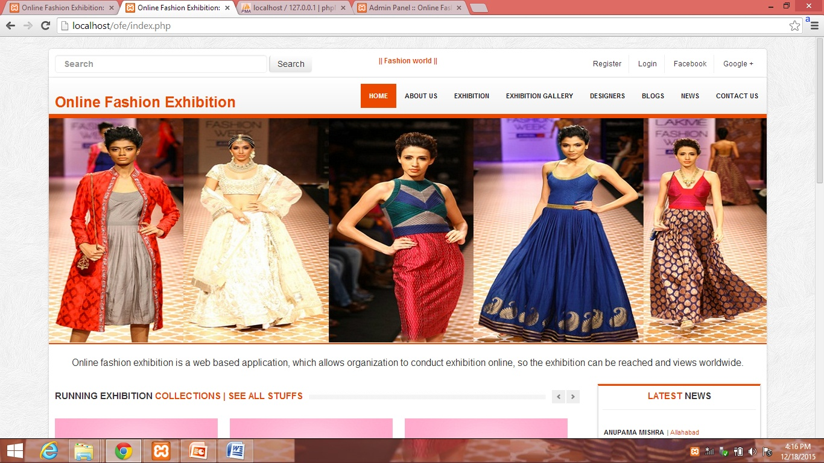

**Create exhibition**

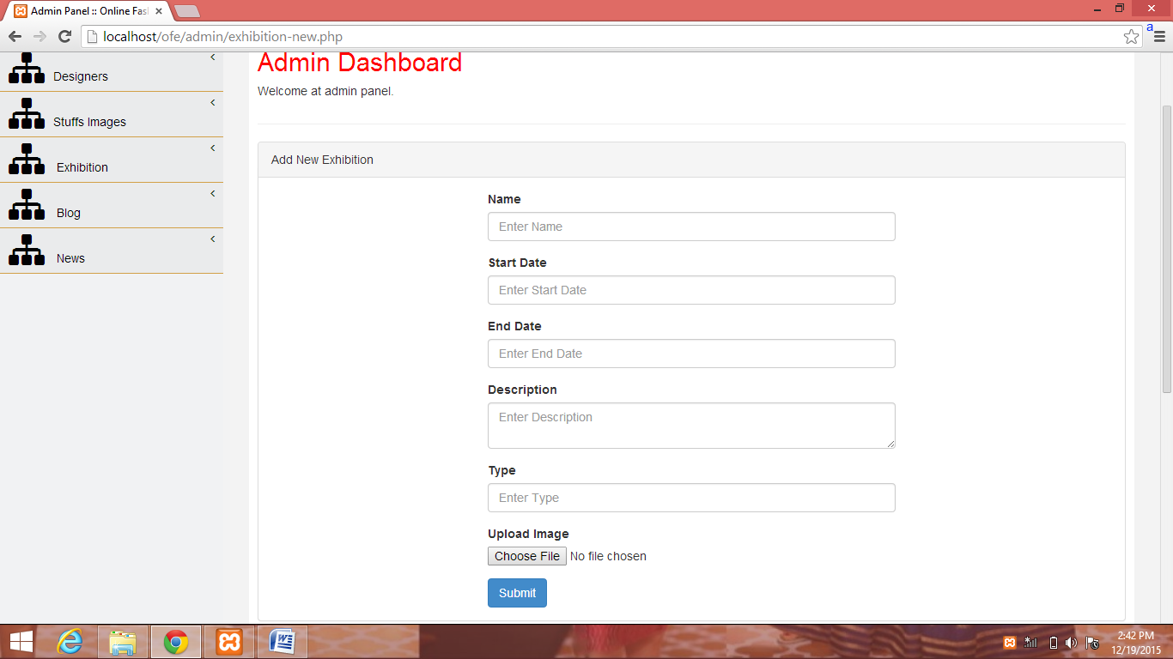

**News**

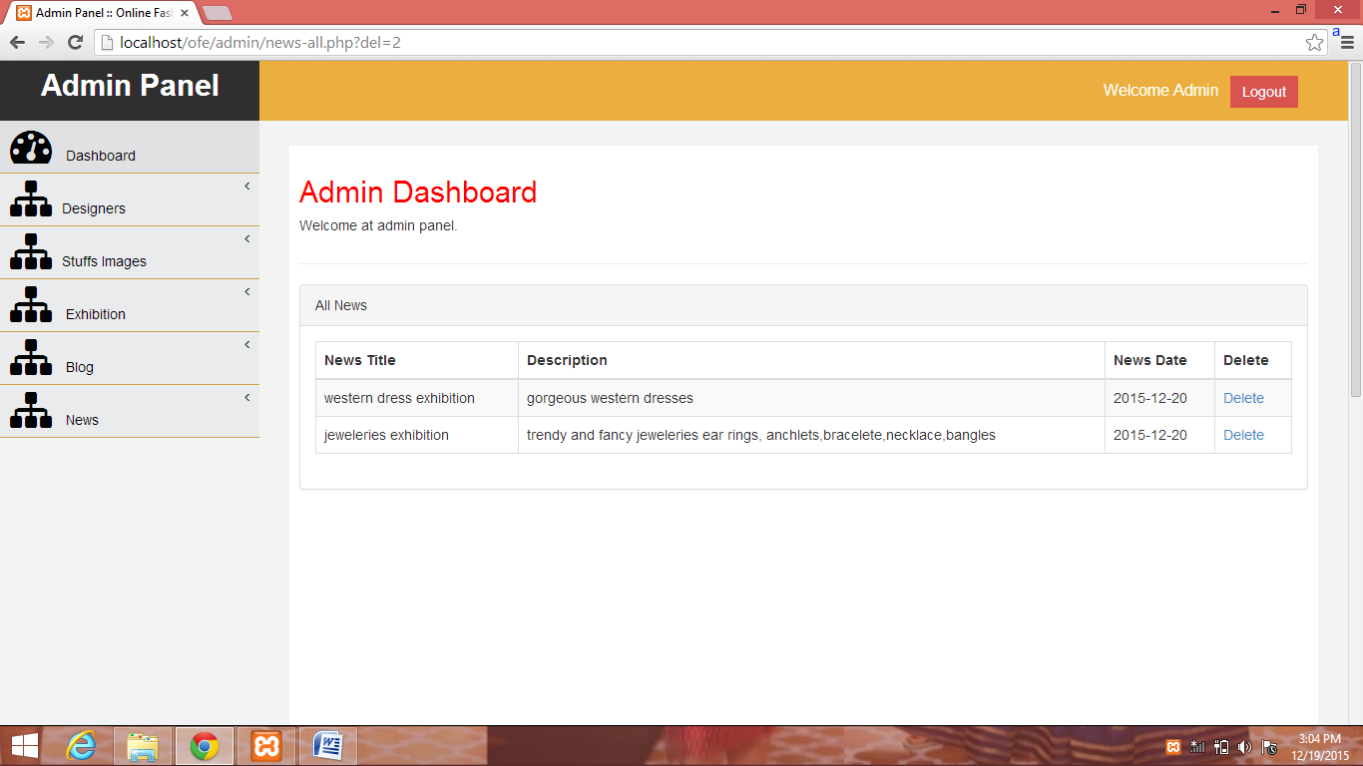

**All Exhibition**

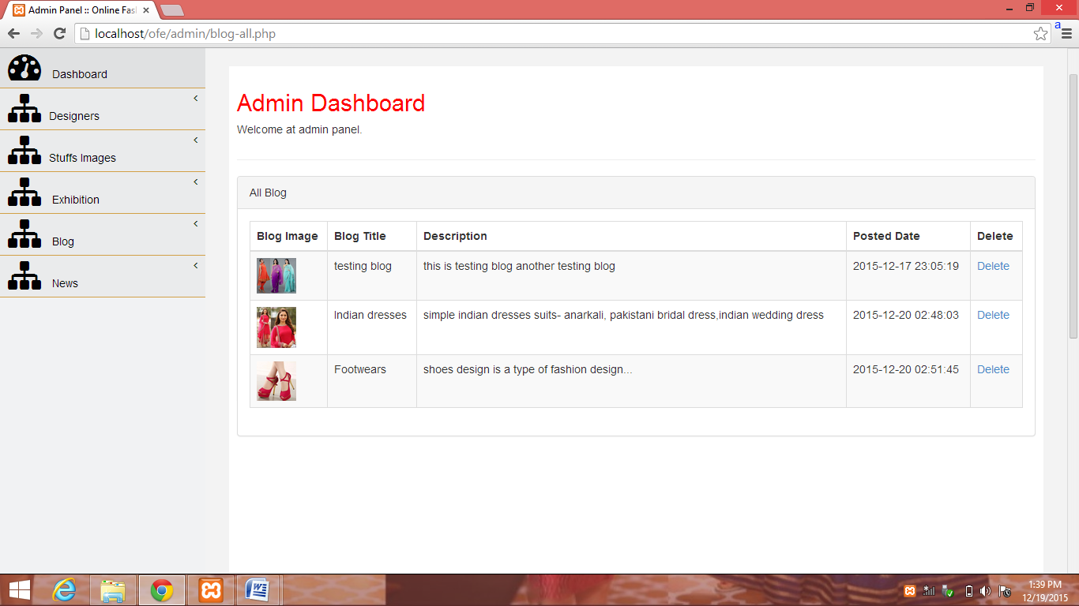

1. ***Application***

**User Manual:**

Some Important instructions you should follow before using the system:

1. The user must be registered before using the system.
2. Registration must be according to the categorization i.e. as a Participants and Exhibitor or as an anonymous.
3. Do not perform things on the website which can harm other’s feelings and sentiments.
4. Use the functionality in accordance with the privileges assigned.
5. The website is designed for sharing information and knowledge between participants, exhibitor and anonymous users try to maintain the environment.

**How to use it……**

* + 1. Register yourself first as an anonymous user or as participants.
    2. Login into your created account with your Id and Password and choose the correct type.
    3. After login your home page is in front of you. And type is written on top of the home page.

1. ***Conclusion***

Internet is known as a pool of information, but finding the relevant information from the internet is such a hard and time consuming task. This is reduced after the invention of the search engines, then to because of their business rules and profit they shows allot of advertising links on their web pages, which again disguise the users and act as a hurdles.

Online Fashion Exhibition provides platform where an online exhibition will be hosted. Participants from different places can participate. The participants will upload their stuffs for exhibition that can be visited by user all over the world. At Online fashion exhibition multiple exhibition can be run at a single time. By this we can save time and cost. A visitor don’t need to come at a exhibition place he/she can see exhibition from his/her home/office or from anywhere with help of internet.

***Future Enhancements***

The future enhancement of the website can have following areas like:

1. Mobile apps will be developed for this project
2. Online shoping facility will be added so that if anyone likes products so he/she can purchage it from his/her home.

**References**

**Websites:**

* [www.google.com](http://www.google.com)
* [www.yahoo.com](http://www.yahoo.com)
* [www.wikipedia.com](http://www.wikipedia.com)
* [www.ask.com](http://www.ask.com)
* [www.wikianswer.com](http://www.wikianswer.com)
* [www.answer.com](http://www.answer.com)
* [www.w3schools.com](http://www.w3schools.com)